Name: Chey Naryvety
ID: IDTB110199
LAP 4
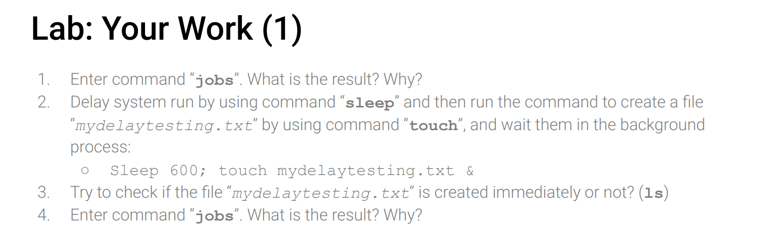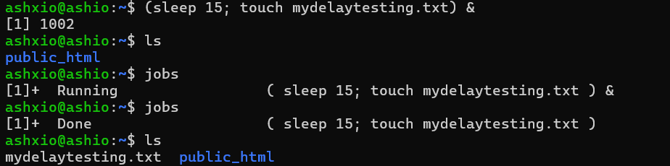
- The first “jobs” doesn’t give any result bcus there is nth running in the background
- The ; tells the system to do the command in order. Sleep command tells the system to wait then do the second command which is to create the file and the & put them both to run in the background.
- The file isn’t created immediately when using ls to check bcus it still have to wait
- Command jobs now show that there is task running, after it’s done the file is now created.
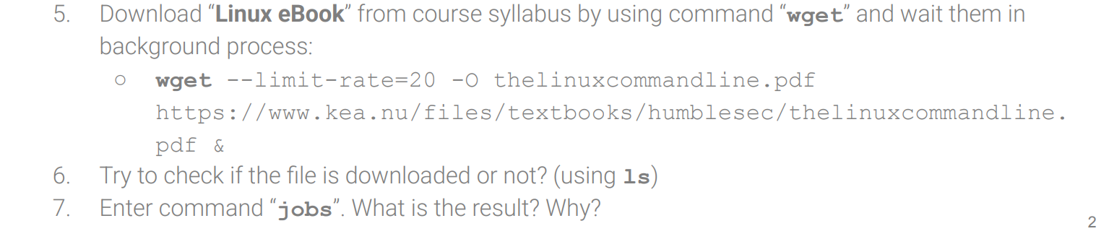
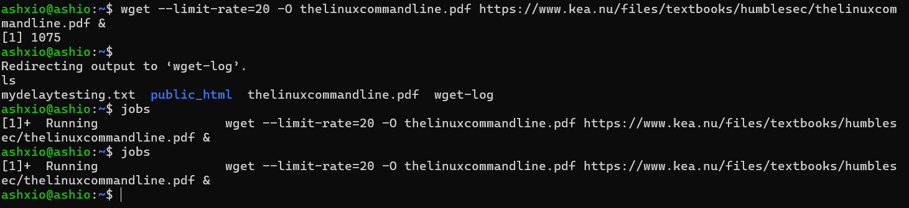
- --limit-rate=20, the file is downloading at 20byte per sec making it super slow
- Using ls will show the file since it was created immediately by using the -o (output doc) but it will be empty until the download is fully done
- Jobs still show the tasking running in the background meaning it is still downloading
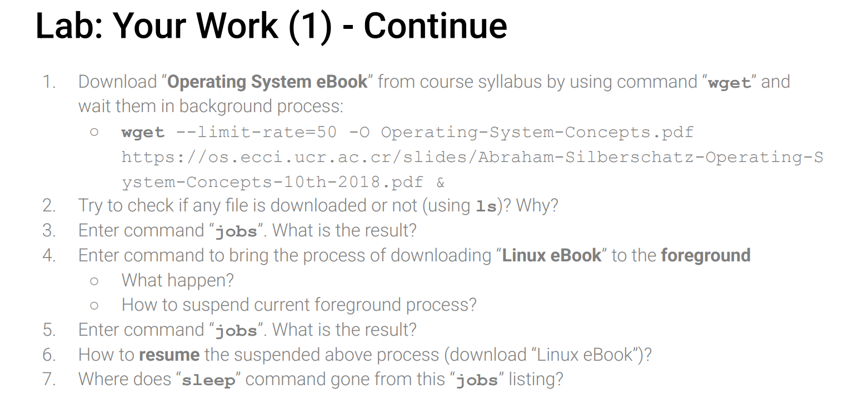
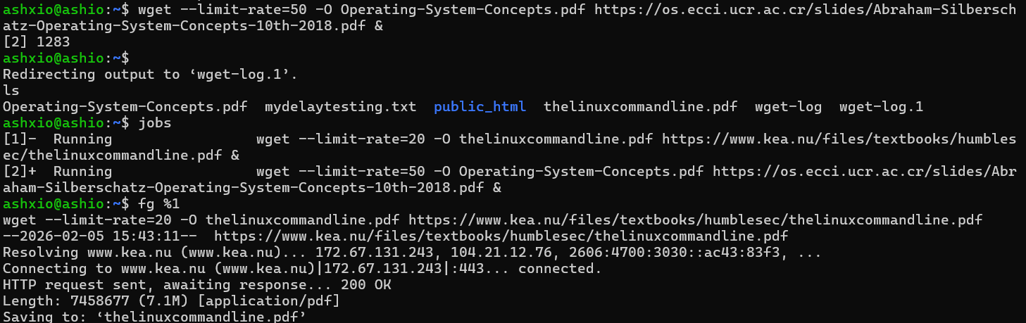
- Using ls will show the file since it was created immediately by using the -o (output doc) but it will be empty until the download is fully done
- Jobs will list two running jobs, one from the last download that is still running
- Once we enter the command to bring the linux ebook to the front we will lose control of the terminal again as it is now a foreground task and it will also show the download status bar. Use crtl z to suspend the current job
- Use bg %1 to resume the download in the background
- The sleep command is gone bcus it has alr finished running
(note: only put the sleep for 15sec cus wanted to test it on a shorter duration)

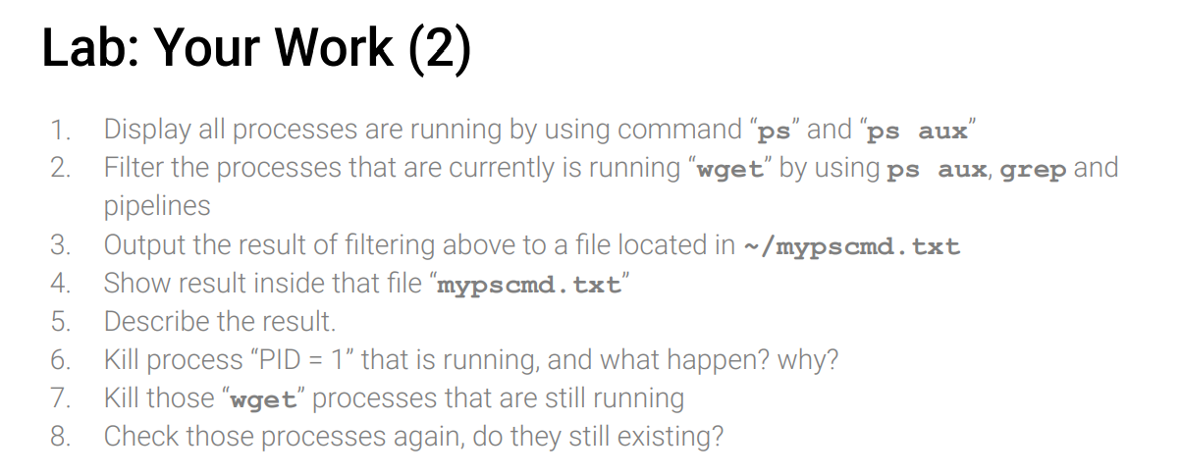
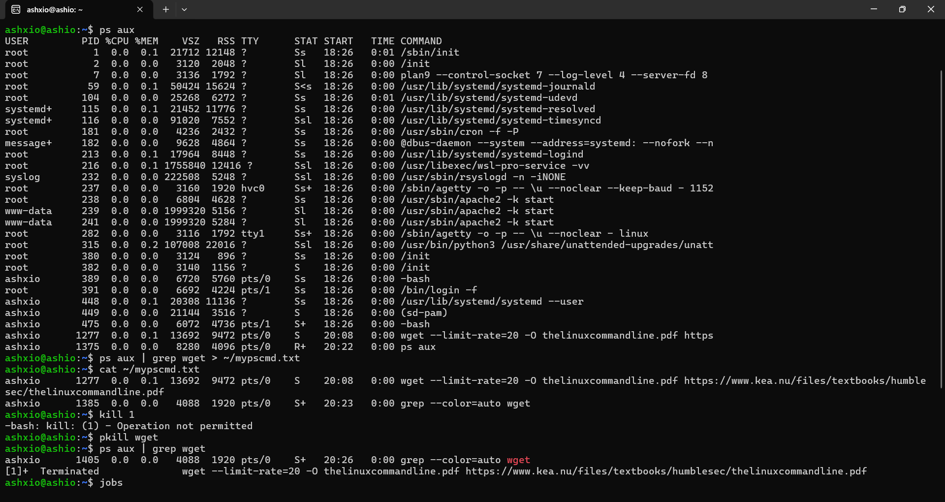
The result shows only the wget commands we ran before
Kill 1 doesn’t work bcus it is the parent of all process so we don’t have perm to kill it or else everything would crash
The wget process don’t exist anymore bcus we already terminated the tasks and the jobs would also show nth

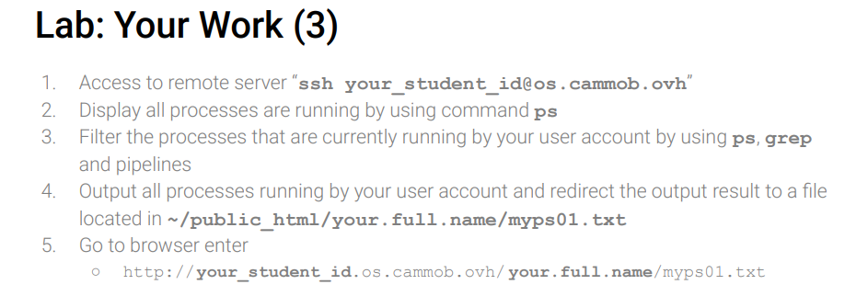
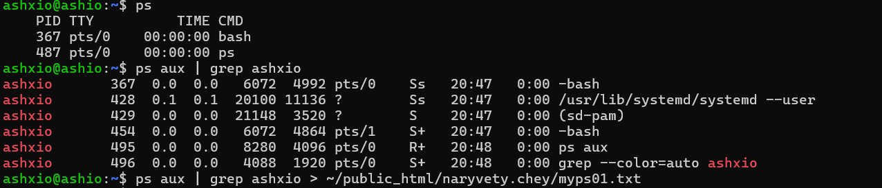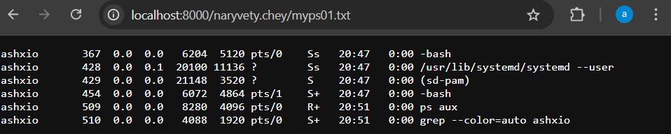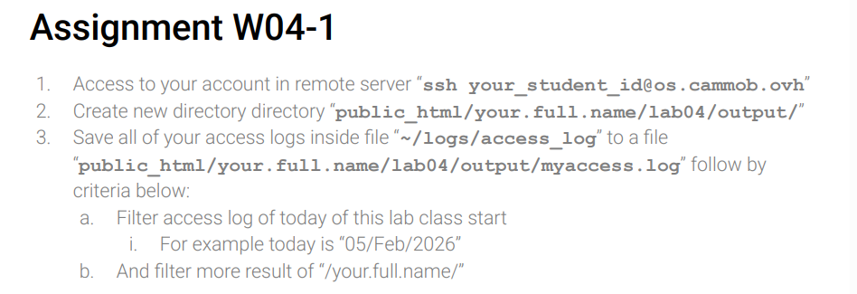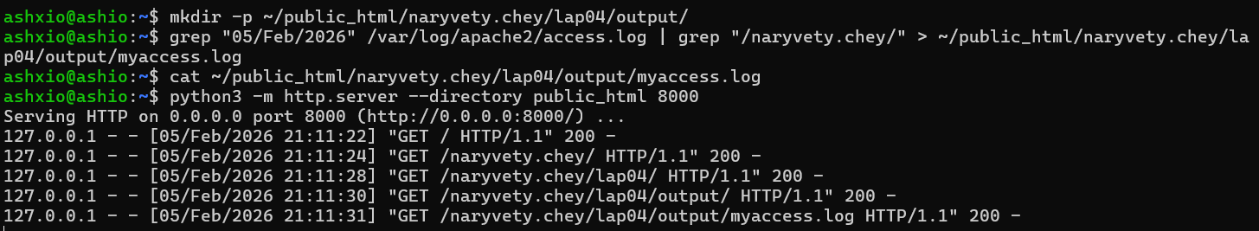
Theres nth cus theres no activity

